Lab Exercise - Create Azure Storage Account using ARM Template and Upload-Download Files

Objective
- Create an Azure Storage Account using an ARM Template
- Create a Blob Container
- Upload a file to Blob Storage
- List files in Blob Container
- Download file from Blob Storage

Prerequisites
- Azure Subscription
- Azure Cloud Shell
- Azure CLI access

Lab Architecture
Resource Group
↓
Storage Account
↓
Blob Container
↓
Upload File
↓
List Files
↓
Download File

Step 1 — Open Azure Cloud Shell
Open:
Azure Portal
Open:
- Cloud Shell
- Select Bash

Step 2 — Set Variables
RESOURCE_GROUP=armstorage-rg
STORAGE_ACCOUNT=stor$RANDOM
CONTAINER_NAME=mycontainer

Note:
- Storage account name must be globally unique
- Use lowercase only

Step 3 — Create Resource Group
az group create \
--name $RESOURCE_GROUP \
--location eastus

Step 4 — Create ARM Template File
nano storagetemplate.json

Step 5 — Paste ARM Template
{
"$schema": "https://schema.management.azure.com/schemas/2019-04-01/deploymentTemplate.json#",
"contentVersion": "1.0.0.0",
"parameters": {
"storageAccountName": {
"type": "string",
"defaultValue": "stor25840"
}
},
"resources": [
{
"type": "Microsoft.Storage/storageAccounts",
"apiVersion": "2023-01-01",
"name": "[parameters('storageAccountName')]",
"location": "[resourceGroup().location]",
"sku": {
"name": "Standard_LRS"
},
"kind": "StorageV2",
"properties": {}
}
]
}

Step 6 — Save File
Press:
CTRL + X
Press Y
Press Enter

Step 7 — Deploy ARM Template
az deployment group create \
--resource-group $RESOURCE_GROUP \
--template-file storagetemplate.json \
--parameters storageAccountName=$STORAGE_ACCOUNT

Deployment takes around 1–2 minutes.

Step 8 — Verify Storage Account
az storage account list \
--resource-group $RESOURCE_GROUP \
--output table

Expected Output:
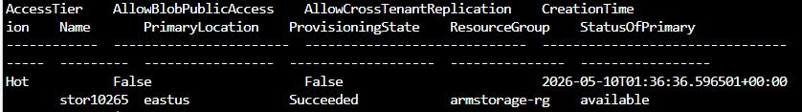

Step 9 — Create Blob Container
az storage container create \
--name $CONTAINER_NAME \
--account-name $STORAGE_ACCOUNT \
--auth-mode login

Step 10 — Create Sample File
echo "Hello Azure Storage Account" > sample.txt

Verify:
cat sample.txt

Expected:
Hello Azure Storage Account

Step 11 — Upload File to Blob Storage
az storage blob upload \
--account-name $STORAGE_ACCOUNT \
--container-name $CONTAINER_NAME \
--name sample.txt \
--file sample.txt \
--auth-mode login

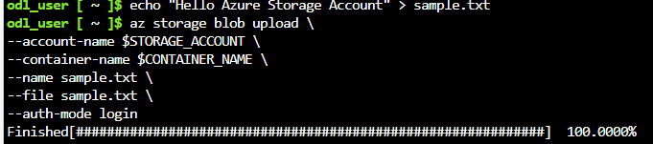

Step 12 — List Files in Blob Container
az storage blob list \
--account-name $STORAGE_ACCOUNT \
--container-name $CONTAINER_NAME \
--output table \
--auth-mode login

Expected Output:
Name
----------
sample.txt

Step 13 — Download File from Blob Storage
az storage blob download \
--account-name $STORAGE_ACCOUNT \
--container-name $CONTAINER_NAME \
--name sample.txt \
--file downloaded.txt \
--auth-mode login

Step 14 — Verify Downloaded File
cat downloaded.txt

Expected Output:
Hello Azure Storage Account

Step 15 — Delete Blob File (Optional)
az storage blob delete \
--account-name $STORAGE_ACCOUNT \
--container-name $CONTAINER_NAME \
--name sample.txt \
--auth-mode login

Step 16 — Delete Resource Group
Cleanup all resources:
az group delete \
--name $RESOURCE_GROUP \
--yes

ARM Template Mapping
Azure Resource | ARM Template Type
Storage Account | Microsoft.Storage/storageAccounts
Blob Container | Managed using Azure CLI
Blob/File | Managed using Azure CLI

Important Azure Blob Concepts
Component | Description
Storage Account | Main Azure storage service
Container | Logical grouping of blobs
Blob | Actual stored file
Upload | Send file to Azure
Download | Retrieve file from Azure

